**6205 assignment1**

1.Your conclusion about the relationship between d, n and l;

d=0.8817*l*n^0.5009

2.Your evidence to support that relationship;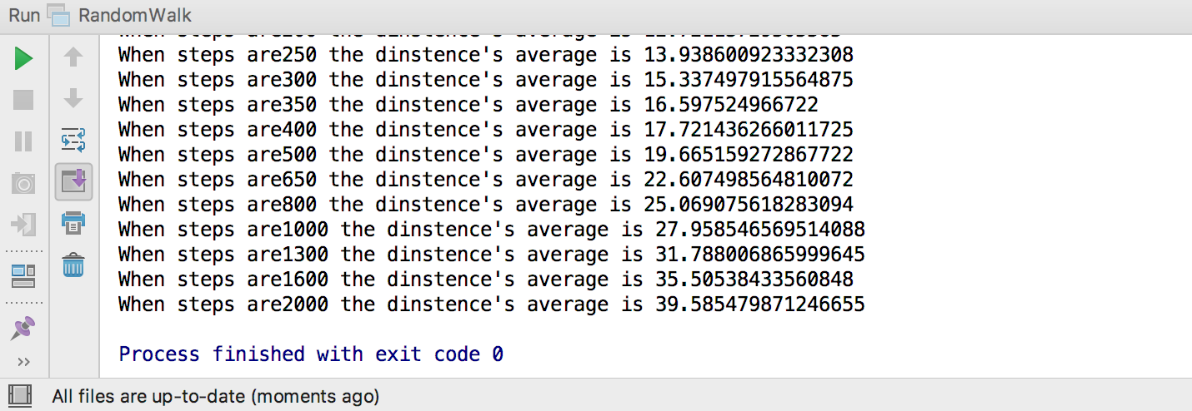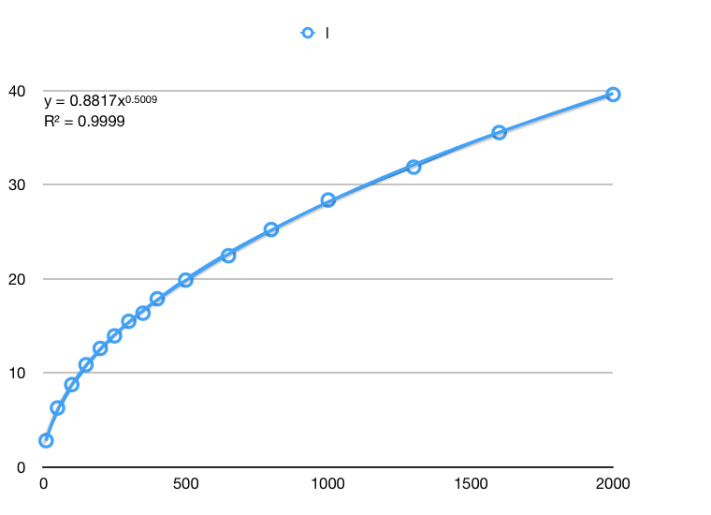

3.Your code (*RandomWalk.java* plus anything else that you changed or created);

This part has been put into the RandomWalk file .

4.Evidence (screen shot) of the unit tests all passing.

